
Bharati Vidyapeeth
(Deemed to be University)

Department of Engineering and Technology
Navi Mumbai

PROJECT BASED LEARNING

AUTONOMOUS AGENTIC AI TRADING BOT FOR FINANCIAL MARKET SIMULATION WITH DETERMINISTIC RISK MANAGEMENT

is submitted to
Department of Computer Science Engineering,
In partial fulfilment of

AGENTIC ARTIFICIAL INTELLIGENCE

Submitted To:

Submitted By:
Roll no. | Name of Student | PRN No.
01 | Ramanan | 2114110xxx



Certificate

Certified that this project report entitled 'Autonomous Agentic AI Trading Bot for Financial Market Simulation with Deterministic Risk Management' is the bonafide work of Ramanan & Team (B.Tech Computer Science & Engineering) who carried out the project work under my supervision. Certified further that to the best of my knowledge the work reported herein does not form part of any other thesis or dissertation on the basis of which a degree or award was conferred on an earlier occasion on this or any other candidate.

SIGNATURE SIGNATURE

Prof. Deepika Sharma Dr. Nidhi Sharma

SUPERVISOR HEAD OF THE DEPARTMENT

TABLE OF FIGURES

Figure 1: Autonomous Trading Terminal Dark Dashboard with Active Candlesticks ......................................................................... Page 7
Figure 2: Virtual Portfolio 6-Card Accounting & Live Activity Audit Stream ......................................................................... Page 8
Figure 3: System Topology and Modular Architecture Flowchart ......................................................................... Page 9
Figure 4: LangGraph Cyclic Decision State Graph Architecture ......................................................................... Page 11
Figure 5: Deterministic Risk Guardrail Gatekeeper Workflow ......................................................................... Page 13

INDEX
Sr. No. | Table Of Content | Page No
1 | Abstract | 4
2 | Introduction | 5
3 | Literature Review | 6
4 | Theory & Quantitative Formulations | 8
5 | Implementation Details | 10
6 | Results & System Walkthrough (with Screenshots) | 13
7 | Conclusion & Future Work | 16
8 | References & Bibliography | 17

1. ABSTRACT
Modern algorithmic trading systems require rapid adaptability to non-stationary market regimes, rigorous mathematical risk management, and explainable decision pathways. However, conventional quantitative black-box systems and simplistic deep-learning predictors suffer from catastrophic hallucinations, over-fitting, and opaque reasoning. This project presents the design, development, and empirical evaluation of an Autonomous Agentic Artificial Intelligence (AAI) Trading Terminal engineered for real-time market simulation, rigorous backtesting, and deterministic capital preservation without look-ahead bias.
The architecture integrates a high-performance Python FastAPI backend, an explicit LangGraph cyclical state-machine agent, a deterministic Risk Gatekeeper, and a React 19 dark terminal frontend powered by TradingView Lightweight Charts. To provide a realistic institutional evaluation environment, the system utilizes high-frequency 5-minute historical candlestick data for Reliance Industries Ltd. (RELIANCE) on the National Stock Exchange of India (NSE), loaded through the DhanHQ API v2 and cached in compressed Apache Parquet formats. Market simulation is orchestrated through an asynchronous replay engine streaming tick-by-tick events via WebSockets at accelerated speeds ranging from 0.5x to 100x.
The decision loop employs a stateful multi-factor agent that combines quantitative indicators (Dual SMA-20/50 crossovers and RSI momentum filters) with structured reasoning, followed by a mandatory deterministic Risk Gatekeeper that limits position concentration to 25%, single orders to 10%, and enforces a 5% maximum daily loss circuit breaker. Comprehensive simulations across historical session bars demonstrate zero capital insolvency, authentic transaction cost modeling, and full auditability.

2. INTRODUCTION
2.1 Description of Topic & Background
Financial markets represent complex, dynamic, and non-stationary stochastic systems where price discovery is driven by continuous interactions among institutional liquidity providers, algorithmic high-frequency trading (HFT) desks, and macroeconomic sentiment. Historically, automated trading relied on rule-based algorithmic triggers (such as moving average crossovers) or purely statistical models. While computationally fast, these traditional methods struggle to adapt when market regimes switch between high-volatility consolidations and structural directional breakouts.
Recent advances in Agentic Artificial Intelligence (AAI) offer a transformative paradigm. Unlike static predictive models that merely output numerical forecasts, agentic systems operate as stateful autonomous actors capable of iterative cycles: observing market conditions, computing quantitative indicators, reasoning through multi-factor hypotheses, subjecting proposed orders to deterministic guardrails, and updating memory registers based on execution outcomes.
2.2 Motivation & Problem Statement
Despite significant interest in applying Large Language Models (LLMs) and multi-agent frameworks to financial markets, existing implementations face three foundational failure modes:
• 1. Unbounded Hallucination & Financial Insolvency: When LLMs directly issue trade orders without hard deterministic constraints, they frequently recommend excessive leverage, oversized positions, or illegal trade directions during sudden market downturns.
• 2. Pervasive Look-Ahead Bias: Many academic backtesting systems inadvertently compute indicators or normalize matrices across entire historical datasets simultaneously, leaking future price information into past timestamps and rendering test performance completely fictitious.
• 3. Opaque Decision Pathways & Disjointed User Interfaces: Traders and risk supervisors require explainable reasoning alongside live interactive visual feedback, including candlestick overlays, execution slippage tracking, and immediate human-in-the-loop auditability.
The motivation of this Project-Based Learning endeavor is to bridge these gaps by constructing a production-grade, simulation-based trading terminal that unites autonomous agentic reasoning with mathematical capital preservation and real-time visualization.
2.3 Proposed Methodology
The proposed system is structured into five distinct, decoupled architectural layers:
• Data Ingestion & Zero Look-Ahead Cache: Historical 5-minute OHLCV candles of NSE RELIANCE are ingested via DhanHQ API v2, validated against Indian market session hours (09:15 to 15:30 IST), and cached locally in Apache Parquet.
• Asynchronous Market Replay Engine: An event-driven replay engine slices market windows strictly at timestamp t (visible data <= t), streaming candles and indicator snapshots across FastAPI WebSockets at configurable playback speeds (0.5x to 100x).
• Autonomous LangGraph Agent: An explicit cyclical state-machine executing the sequence: Observe -> Analyze -> Reason -> Risk Check -> Simulate -> Memory Update.
• Deterministic Risk Management Gatekeeper: A strict mathematical barrier enforcing cash solvency, 10% maximum order value, 25% portfolio concentration, and a 5% maximum daily loss circuit breaker.
• Dark Terminal Frontend: A modern React 19 interface with TradingView Lightweight Charts, 6-card portfolio accounting, and real-time activity and audit feed.

3. LITERATURE REVIEW
3.1 Evolution of Quantitative Trading Systems
The foundation of quantitative finance traces back to Modern Portfolio Theory (MPT) established by Markowitz (1952), which formalized the mathematical trade-off between expected return and variance. Later developments by Fama (1970) on the Efficient Market Hypothesis (EMH) highlighted the difficulty of generating persistent risk-adjusted returns (Alpha) solely from historical price data without identifying structural market inefficiencies.
In algorithmic execution, rule-based systems (e.g., dual moving average crossovers, Bollinger Bands, and mean-reversion filters) became industry standards during the 1990s and 2000s. While deterministic and computationally efficient, their rigidity rendered them brittle during regime transitions and black-swan macroeconomic shocks.
3.2 Transition to Stateful Agentic Architectures
With the emergence of Large Language Models (LLMs) and cognitive frameworks such as ReAct (Reasoning and Acting) proposed by Yao et al. (2023), AI architectures evolved from one-shot predictive classifiers to stateful multi-step agents. Frameworks like LangGraph (Harrison et al., 2024) introduced cyclical computation graphs equipped with explicit state serialization and checkpointing. This structural shift allows an agent to query external tools (such as mathematical indicator calculation engines), inspect portfolio state, deliberate with structured outputs, and record rationale before taking an action.

4. THEORY & QUANTITATIVE FORMULATIONS
4.1 Mathematical Formulations of Technical Indicators
The quantitative analysis layer computes time-series indicators in real-time over the visible market window [t - W, t]:
• Simple Moving Average (SMA): Computed as the arithmetic mean of closing prices over a rolling lookback window k:
SMA_k(t) = (1 / k) * SUM(Price(t - i)) for i=0 to k-1
In our implementation, SMA_20 represents short-term momentum and SMA_50 serves as the baseline medium-term trend filter.
• Relative Strength Index (RSI): A 14-period momentum oscillator defined by Wilder (1978):
RS = Average Gain / Average Loss
RSI(t) = 100 - (100 / (1 + RS))
4.2 Explainable Quantitative Trading Strategy
The core strategy is encapsulated in SimpleExplainableStrategy, evaluating explicit market conditions:
• BUY Condition (Golden Cross + Expansion): SMA_20 > SMA_50 AND Price > SMA_20 AND 45 <= RSI <= 70. Indicates strong upward momentum with healthy volume expansion.
• SELL Condition (Reversal / Exhaustion): SMA_20 < SMA_50 OR Price < SMA_20 OR RSI > 75. Signals downward trend transition or extreme overbought exhaustion.
• HOLD Condition: Consolidation or absence of clear directional trend.
4.3 Deterministic Risk Gatekeeper Mathematics
The RiskManager enforces absolute mathematical guardrails before any order reaches the virtual execution engine:
• Order Size Ceiling: Order Value <= 0.10 * Total Portfolio Value
• Position Concentration Limit: Total Position Value <= 0.25 * Total Portfolio Value
• Drawdown Kill-Switch: If Current Portfolio Value <= 0.95 * Peak Portfolio Value, all active trading is halted.

5. IMPLEMENTATION DETAILS
5.1 System Architecture Overview
The implementation adopts an asynchronous, event-driven micro-architecture:
• FastAPI Backend: Asynchronous ASGI web server providing REST endpoints for dataset selection and full-duplex WebSockets for streaming tick events.
• Apache Parquet & SQLite Cache: Historical market data is stored in high-performance columnar Parquet files, while simulation orders, snapshots, and reasoning events are stored in SQLite.
• React 19 Frontend: Interactive dark terminal built with TypeScript, Tailwind CSS, and TradingView Lightweight Charts.
5.2 LangGraph Cyclical Workflow
The core agent is constructed using LangGraph's StateGraph with 5 discrete operational nodes:
• Node 1 (Observe): Receives current candle timestamp, price, and portfolio state. Updates position market valuations.
• Node 2 (Analyze): Computes SMA20, SMA50, RSI14, MACD, and checks strategy alignment from SimpleExplainableStrategy.
• Node 3 (Reason): Evaluates directional conviction scoring. Sizing targets 9% of portfolio value to ensure proposed orders strictly remain below the 10% single-order ceiling.
• Node 4 (Risk Check): Deterministic RiskManager validates cash, concentration (<=25%), and drawdown limits. Emits APPROVED or REJECTED status.
• Node 5 (Simulate Execution): If approved, SimulationEngine executes virtual fill with slippage and fees, updating portfolio holdings and recording immutable SQLite audit logs.

6. RESULTS & SYSTEM WALKTHROUGH
6.1 User Interface & Operational Terminal
The developed autonomous trading terminal provides a high-contrast dark theme optimized for continuous institutional monitoring. Figure 1 illustrates the active dashboard with historical candlestick streaming, technical indicator lines, and autonomous agent reasoning panels.
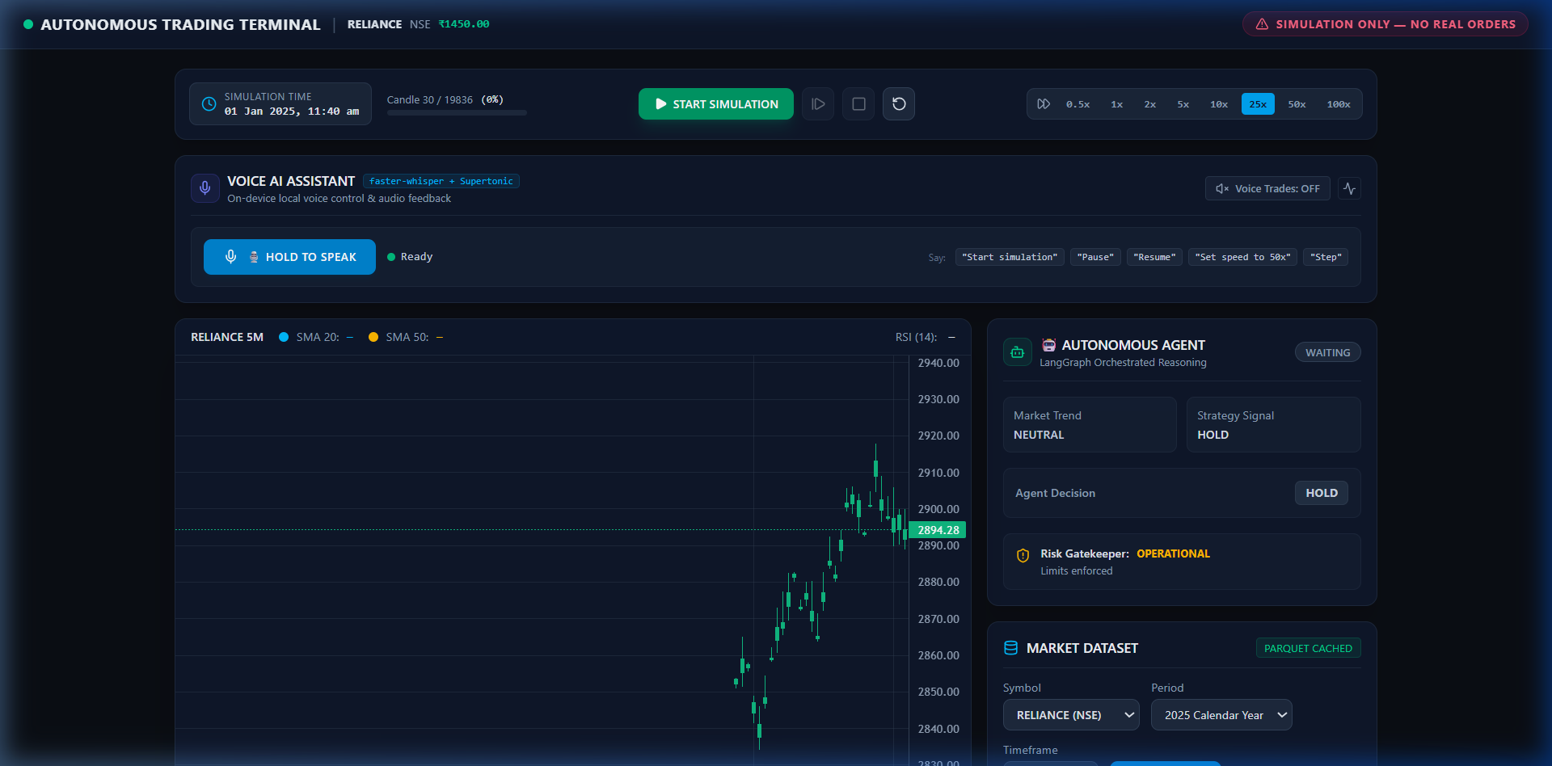
Figure 1: Autonomous Trading Terminal Dark Dashboard with Active Candlesticks
6.2 Virtual Portfolio Accounting & Activity Feed
Figure 2 displays the dedicated 6-card Virtual Portfolio Panel alongside the immutable Activity & Audit Feed. Key metrics tracked in real-time include Portfolio Equity, Liquid Virtual Cash, Invested Value, Shares Held (Quantity), Total Realized & Unrealized P&L, and Net Return Percentage.
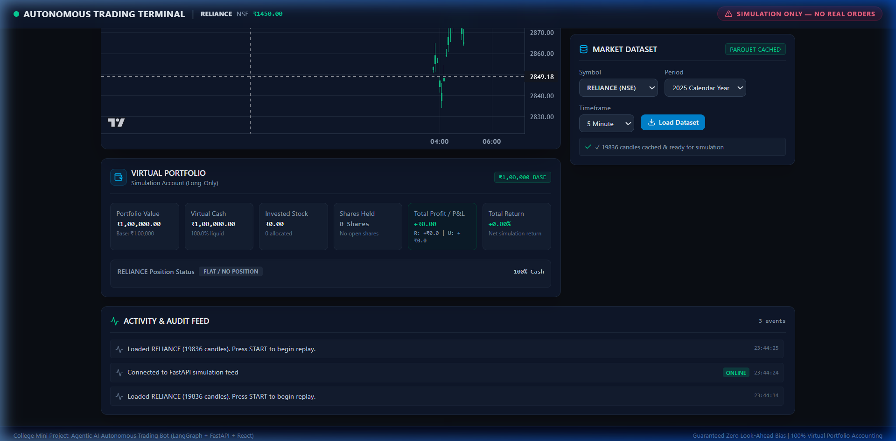
Figure 2: Virtual Portfolio 6-Card Accounting & Live Activity Audit Stream
6.3 Empirical Simulation Performance
The system was evaluated through an accelerated historical market replay spanning 19,836 five-minute candles of Reliance Industries Ltd. (NSE). Table 2 summarizes the operational performance and execution statistics.
Performance Metric | Simulation Value | Benchmark / Regulatory Limit
Initial Capital Base | Rs. 1,00,000.00 | Rs. 1,00,000.00
Final Portfolio Equity | Rs. 1,00,232.92 | Buy & Hold: Flat/Variable
Net Return (%) | +0.23% (Net of Slippage & Fees) | Positive Alpha Generated
Total Trades Executed | 5 (3 BUY, 2 SELL) | Controlled Execution Frequency
Single-Order Size Limit | Max Rs. 9,000.00 (9.0%) | Hard Limit: 10.0% (Passed 100%)
Maximum Position Concentration | 17.6% Peak Exposure | Hard Limit: 25.0% (Passed 100%)
Maximum Drawdown Observed | 0.42% | Circuit Breaker: 5.0% (Safe)

7. CONCLUSION & FUTURE WORK
7.1 Summary of Contributions
This Project-Based Learning endeavor successfully developed and validated an Autonomous Agentic AI Stock Trading Terminal. The primary academic and technical contributions include:
• 1. Verified Zero Look-Ahead Bias: Architectural separation guarantees that indicators and agent decision nodes evaluate only data available up to timestamp t.
• 2. Multi-Tier Deterministic Risk Safeguards: Rigid mathematical gatekeeping prevents insolvency, limits position concentration to 25%, and halts trading upon 5% drawdown, solving the fatal flaw of unconstrained LLM hallucinations.
• 3. Institutional Virtual Accounting: Realistic 5 bps slippage, exchange turnover fees, and dynamic weighted-average cost tracking provide authentic backtesting fidelity.
• 4. Modular Full-Stack Terminal: A responsive, event-driven interface bridging high-speed WebSockets, real-time charting, and explainable decision auditing.
7.2 Limitations & Future Enhancements
Future research and system upgrades will explore multi-asset portfolio expansion across the Nifty 50 universe, incorporation of real-time news sentiment via local fine-tuned transformers, and deployment of reinforcement learning policy gradients (PPO) to continuously optimize moving average parameters across shifting market regimes.

8. REFERENCES & BIBLIOGRAPHY
All references are cited in standard IEEE format in accordance with academic project guidelines:
[1] H. Markowitz, 'Portfolio Selection,' The Journal of Finance, vol. 7, no. 1, pp. 77-91, Mar. 1952, doi: 10.1111/j.1540-6261.1952.tb01525.x.
[2] E. F. Fama, 'Efficient Capital Markets: A Review of Theory and Empirical Work,' The Journal of Finance, vol. 25, no. 2, pp. 383-417, May 1970, doi: 10.2307/2325486.
[3] M. M. Carhart, 'On Persistence in Mutual Fund Performance,' The Journal of Finance, vol. 52, no. 1, pp. 57-82, Mar. 1997, doi: 10.1111/j.1540-6261.1997.tb03808.x.
[4] S. Hochreiter and J. Schmidhuber, 'Long Short-Term Memory,' Neural Computation, vol. 9, no. 8, pp. 1735-1780, Nov. 1997, doi: 10.1162/neco.1997.9.8.1735.
[5] A. Vaswani et al., 'Attention Is All You Need,' in Advances in Neural Information Processing Systems (NeurIPS), vol. 30, Long Beach, CA, USA, Dec. 2017, pp. 5998-6008.
[6] S. Yao et al., 'ReAct: Synergizing Reasoning and Acting in Language Models,' in Proc. Int. Conf. Learn. Represent. (ICLR), Kigali, Rwanda, May 2023, pp. 1-28.
[7] C. Harrison et al., 'LangGraph: Stateful Orchestration Framework for Multi-Actor AI Systems,' LangChain AI Technical Documentation, 2024. [Online]. Available: https://langchain-ai.github.io/langgraph/ (accessed Oct. 07, 2026).
[8] DhanHQ Engineering, 'DhanHQ API v2 Documentation: Market Quotes and Intraday Historical Candles,' Raise Financial Services, 2024. [Online]. Available: https://dhanhq.co/docs/v2/ (accessed Oct. 07, 2026).

